PRM Release MillFrame 4.1.0

Client Publisher Console (CPC) User Guide

Confidential and Proprietary
© 2016 Milliman, Inc. All rights reserved.
Milliman® is a trademark of Milliman, Inc.
All other trademarks belong to their respective owners
This manual and its contents are the confidential property of Milliman, Inc. and are prepared for the exclusive use of Milliman, Inc. and its subscribing clients. Any distribution or reproduction, intentional or unintentional, of any materials contained herein without the express written permission of Milliman, Inc. is prohibited.
For additional information, please contact our technical support team by email: prm.support@milliman.com

Introduction
Milliman PRM Analytics is a predictive analytics solution capable of predicting any number of healthcare management risks. The primary predictive analytics are the Opportunity Prospective Scores.
Milliman PRM Analytics is not a standalone solution. It can also be integrated with an existing care management system for comprehensive care management. The PRM Care Coordinator Reports provide care managers with a comprehensive view of recent patient clinical and claims activity, making management more efficient and effective.
Milliman PRM Analytics are backed by more than 65 years of experience in healthcare consulting, data analytics, operational analysis and problem solving. The solutions offered by this tool leverage a unique reporting structure and custom analytics that help meet coming healthcare challenges head on.

This user guide is designed to give users an understanding of the latest features of the PRM Client Publisher Module, the functionality of each section and step by step instructions for using the system.
Please note that these instructions are ONLY meant for internal users who have been granted administrator access.
Note: Access to various functionality is dictated by what was enabled for the role assigned to the user and the options enabled for the client. For illustration purposes, all of the functionality is enabled in the screen shots shown below.

Technical Support
If you are having any technical difficulty with the product, please contact our technical support team by email: prm.support@milliman.com
Note: For the purpose of this user guide, all data has been de-identified to protect patient’s personal health information (PHI) in accordance with the Health Insurance Portability and Accountability Act of 1996 (HIPAA).

PRM Client Publisher Console

Overview
PRM Client Publisher Console (CPC) is an application that allows authorized users to publish updated contents to the PRM production server. This functionality is limited to updating “existing” content on the server. In the event “new” content is required on the PRM server, a request should be directed to PRM support to create the initial containers for the new project, which can then be updated via the Client Publisher Console.

Launching a Client Publisher Console
- Login in to the Web Portal
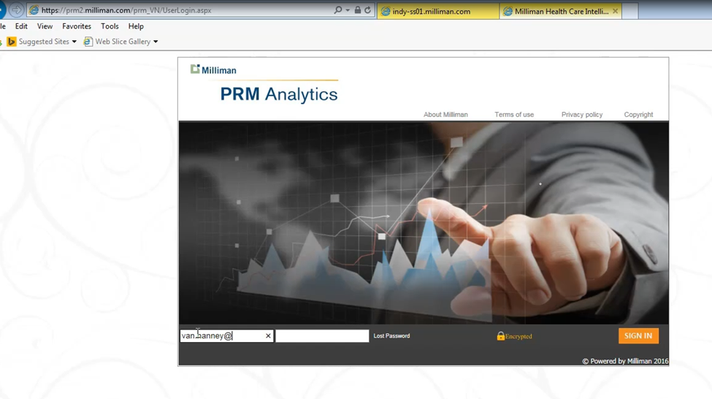
- Click on the Publish Content menu item. The content tab is visible only to users that are authorized to publish contents. If a user is authorized to publish contents for a single Project then click on Publish content will navigate the user to Publish content page otherwise if a user is authorized to publish contents for multiple Projects then a drop down will be available to show each collection of reports.

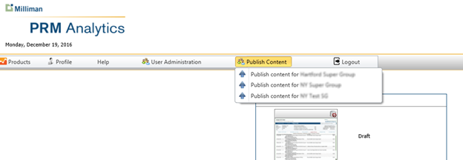

3. Clicking on a specific menu item will navigate to the Client Publisher Console for that menu item. All associated reports for that menu item will be displayed in the Client Publisher Console main page.
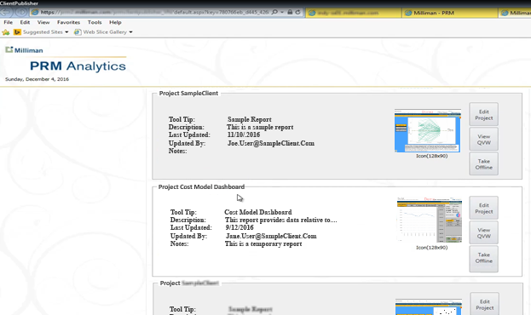

Client Publisher Console User Interface

User Interface Layout Overview
The CPC user interface is organized into sections called ‘Projects’. A project will exist for each report that you have rights to publish. A project is a collection of all the items related to your report that will be displayed via the web portal or drives the behavior of the system as related to the report. Each project section is contained within a grouping box with the project title in the upper left hand corner. Each project container has identical functionality as other project containers on the same page, and differ only in the report and report artifacts for the particular report.

Editing/Updating a Project

- Click on Edit Project.
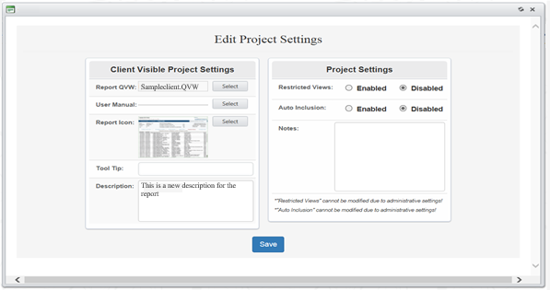
- An Edit Project Settings box opens where both Client Visible Project Settings and Project Settings may be viewed.

- The Client Visible Project Settings represents items visible via the web portal by users, these items consist of
- The Report QVW
- A User Manual
- Tool Tip to help the user understand more details
- A brief description of the QVW

- Project Settings represents items that drive system behavior; these items are not directly viewable via the web portal by users.
- Restricted Views
- Auto Inclusion
A Notes field is also included to describe how the QVW has been edited or modified. In order to save changes, the Client Publisher hits the Save button.

Publishing an updated report that is associated to a group contained in a Super Group
- As previously mentioned, when you make changes in the Client Visible Project Settings, they are reflected in the Report Display in the Web Portal. The screen print below is added just for your information to show the corresponding section on Web Portal application.
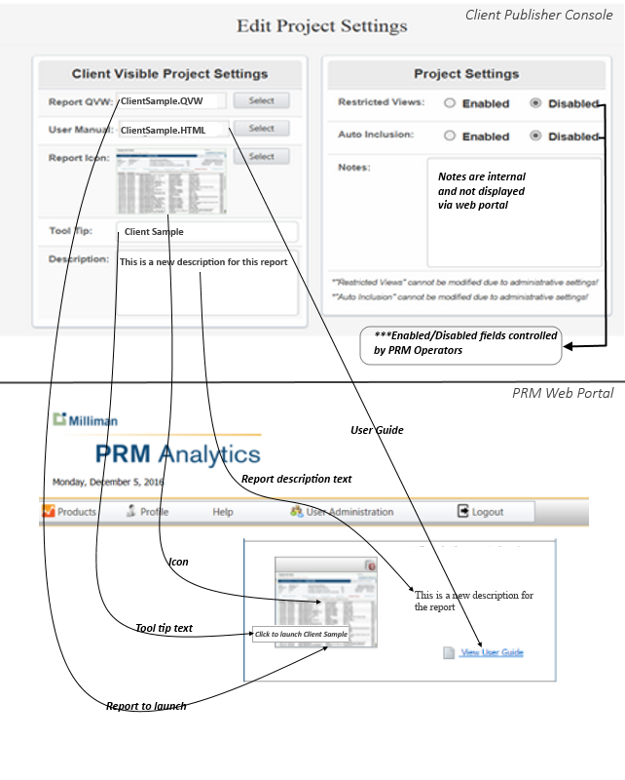

Review of stages of reports before being pushed to production
- Clicking on the Report QVW - Select button opens the file upload browse control and uploads the new QVW to the server.
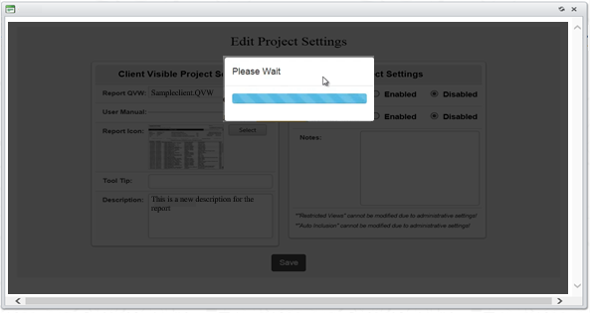

Begin report processing
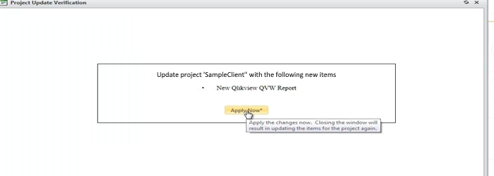

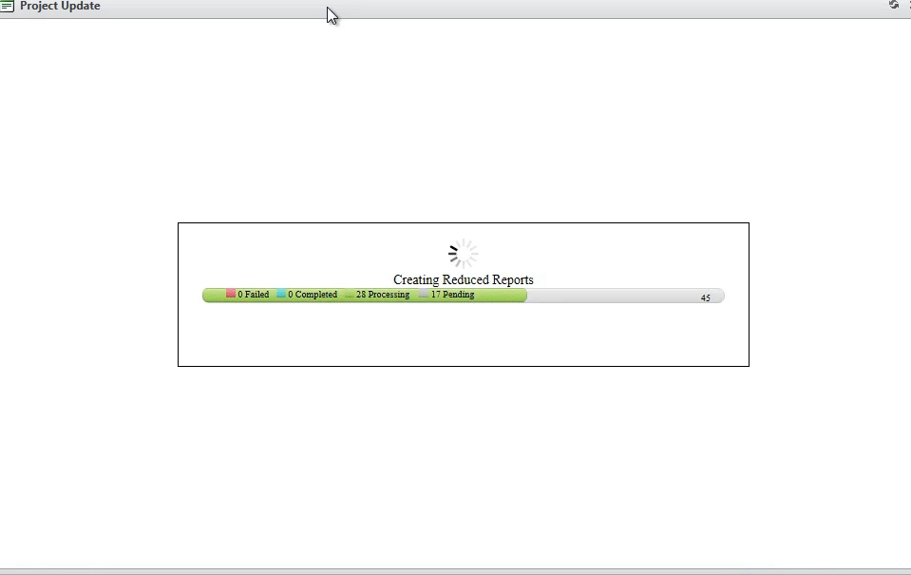
Once started – report reduction takes a while to complete and is dependent upon the number of users and the complexity of the report being reduced.

13. The processing reduces a report for the selections of each user that exists in the group as applied to the master report just uploaded. The reduced report will be associated with the user’s account, such that the web portal will launch the reduced report (if available).

14. The blue portion of the bar indicates reports which have been processed while green represents accounts pending processing.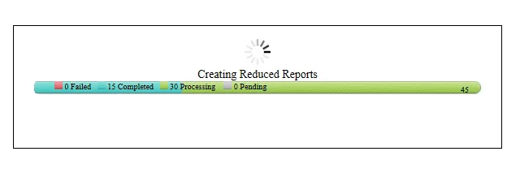

15. After reduction processing is complete. A window with several tabs will be displayed. Each tab contains various status information as related to the reduction process.
16. The first tab is the “Summary” tab.
[MISSING SCREENCAP]
17. The second tab is the “Failed Selections Per User” tab.
[MISSING SCREENCAP]
18. The third tab is the “New Selectable Items” tab.
[MISSING SCREENCAP]
19. The fourth tab is the “Reduction Status” tab.
[MISSING SCREENCAP]

20. The fifth tab is the “Review/Approval” tab. For this iteration of the processing user Jane User is missing the selection for “Sample Surgical, Inc(0000)”. Since this was the only selection made for the user, and the selections is not available – the user does not have a report attached to their account as designated by “No” in the QVW available column.

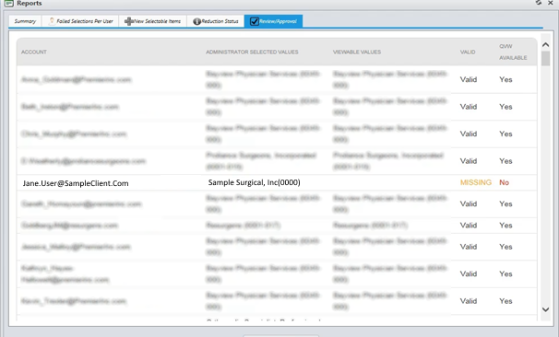

18. At the bottom of the report is the Publish button.
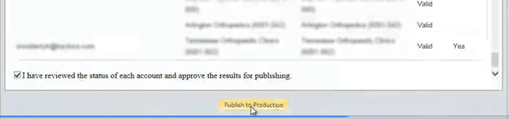

19. Once you check the “review” check box, the “Publish to Production” button will be enabled.
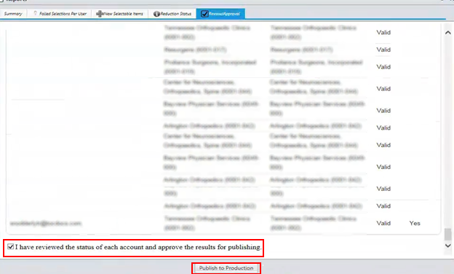

Once “Publish to Production” has been clicked, all report information, user information and reduced reports are uploaded to the production server.

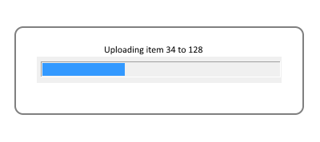
This is an example of the successful publishing of a project.

Viewing a Report
20. Clicking on View QVW will launch the report associated with this project.
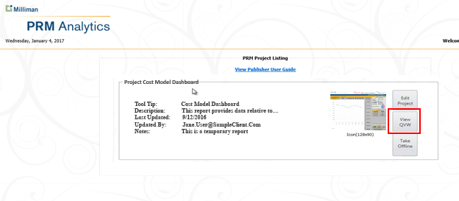

Taking a Report Online/Offline
21. Click on Take Offline. A box will let the user know that using this feature makes the report unavailable to other users.

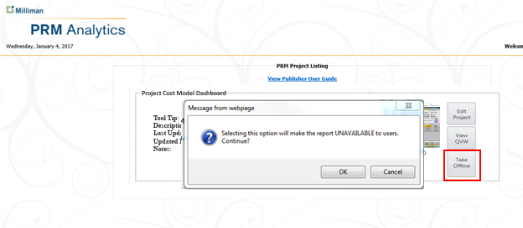

Prevention of ePHI Breaches
Periodically when updating report content, there will scenarios due to complex data changes and/or reduction failures, the ePHI data could be exposed when updating. Thus the Client Publisher Console requires the reduction report to be reviewed (review checkbox) before it will allow the operator of the application to push data to the production server. It is important to note, ePHI data is secure until the “Push to Production” button is clicked. After “Push to Production” is clicked, the data is made live to end-users.
In the final “Review/Approval” report – any data that will be shown to end-users that is not appropriate is signified by the red “PHI BREACH” notification for the user’s account. The system will attempt to provide information as to the specifics of the inappropriate data by displaying the data contained in the report that is flagged as should not be shown. For the sample report below user Tom User’s report contains information that was not part of the original selections and should not be displayed to the user.

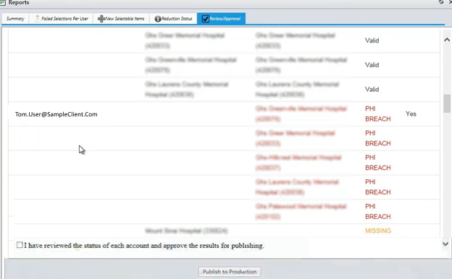
27. If the review checkbox is checked and the Publish to Production button is clicked, this report would be published to the server. The user - Tom User would be able to see PHI that he should not see. This would be a PHI Breach scenario. However, until the Publish button is pushed, no leakage of PHI content has occurred as a result of this processing.

